Team Details:
Sr. No. | Name | Enrollment No.
Team Member 1 | Angat Shah | 202203103510097
Team Member 2 | Yash Patel | 202203103510228
Team Member 3 | Gati Shah | 202203103510261
Team Member 4 | Fenil Shilodre | 202203103510041
Team Member 5 | Sarth Chaudhari | 202303103510106

Objective
The objective of the ROI Vision Builder project is to develop a web-based application that allows businesses, startups and project managers to visually simulate and calculate Return on Investment (ROI) for various business scenarios and decisions.
This tool is designed to empower users with a clear, intuitive interface to estimate outcomes, weigh costs against returns and make data-driven strategic choices. It supports interactive modules that guide users through different financial models to assess profitability, payback periods and net returns.
Code Snippets for Key Functions
- ROI Calculation
export const calculateROI = (
averageAnnualProfit: number,
totalInvestment: number
): number => {
if (totalInvestment === 0) return 0;
return (averageAnnualProfit / totalInvestment) * 100;
};

- NPV
export const calculateNPV = (
cashFlows: number[],
initialInvestment: number,
discountRate: number
): number => {
// Convert discount rate to decimal
const rate = discountRate / 100;

Output
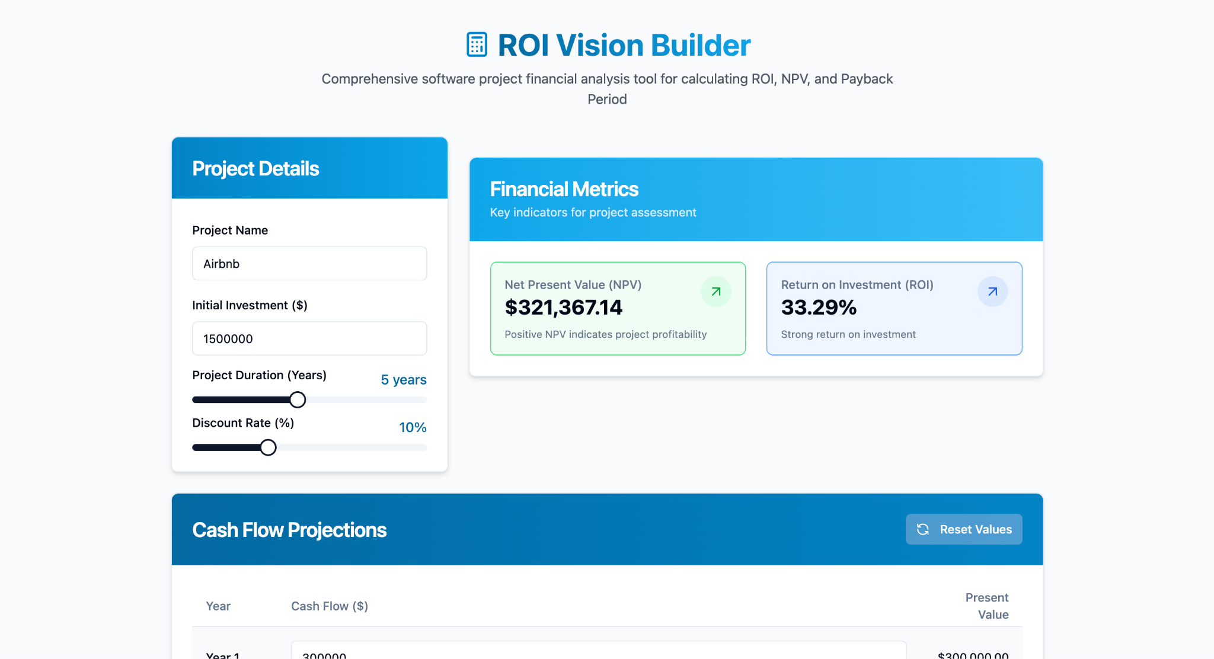

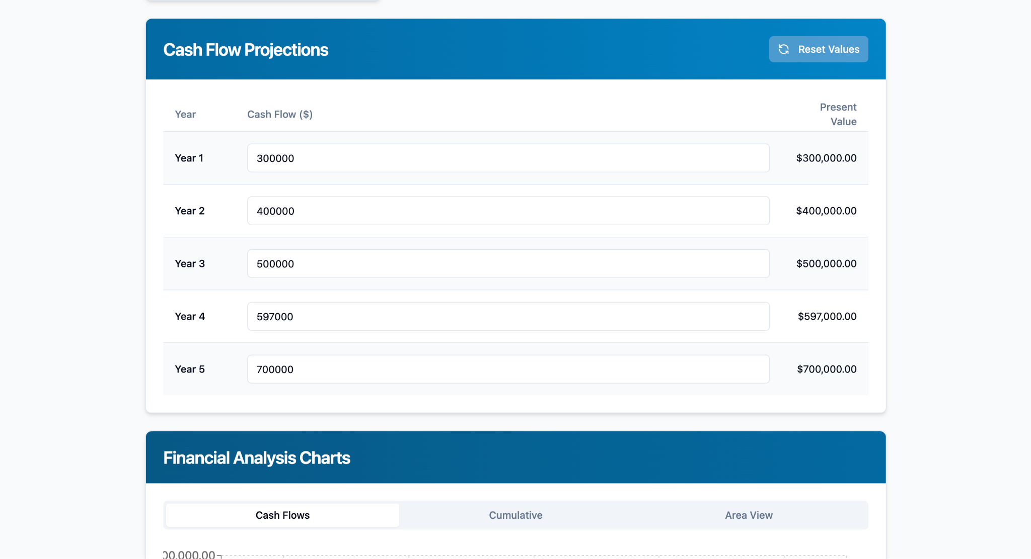

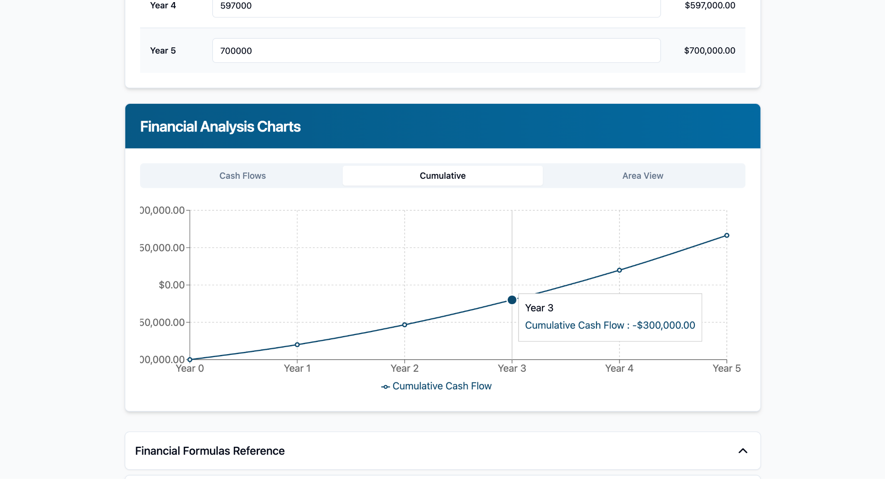

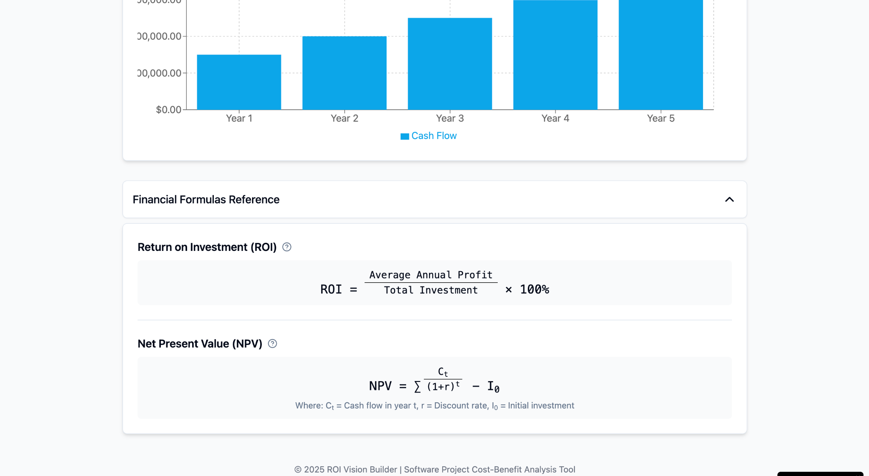

Tools / Technologies
- React.js – Frontend library for building interactive UI.
- TypeScript – Superset of JavaScript providing static typing and improved development experience.
- JavaScript – Programming logic.
- Lovable / Low-code platform – (Specify exact tool/platform used).
- Visual Studio Code – Development Environment.
- Firebase (optional) – For user authentication or cloud storage.
- Git & GitHub – Version control and collaboration.

Future Scope
- Integrate AI-powered forecasting for ROI prediction based on historical data.
- Add user authentication and cloud-based profile/project storage.
- Export results as PDF or Excel reports for stakeholders.
- Support for industry-specific templates (e.g., marketing ROI, SaaS, manufacturing).
- Include a risk analysis module for comprehensive financial planning.
- Mobile version using React Native.

